📘 Assignment: Linux Essentials

🔹 Task 1: Install Ubuntu on a Virtual Machine
Objective: Install Ubuntu Linux using a virtual machine and verify successful login.
Steps:
- Install VirtualBox or VMware Workstation Player.
- Download the latest Ubuntu Desktop ISO from the official Ubuntu website.
- Create a new Virtual Machine with the following configuration:
  - Name: Ubuntu Desktop
  - RAM: 4 GB
  - Processors: 2
  - Storage: 25 GB (Dynamic)
- Mount the Ubuntu ISO and start the virtual machine.
- Complete the Ubuntu installation.
- Log in using your created user account.
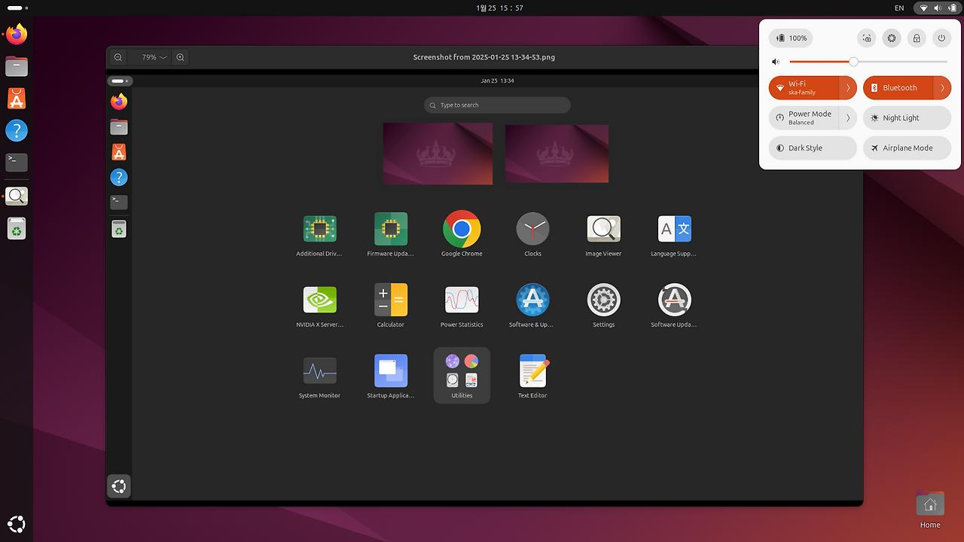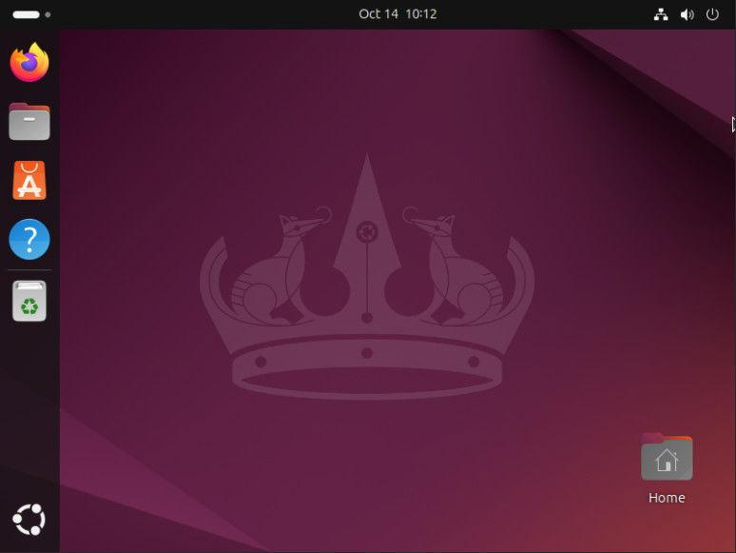
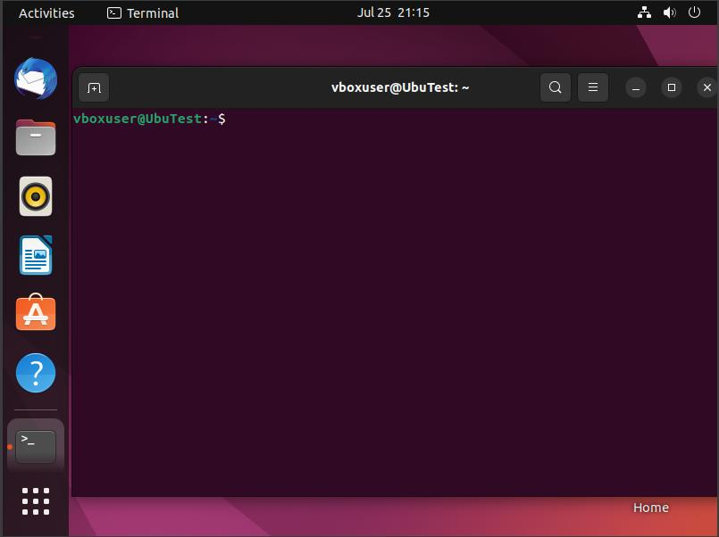

🔹 Task 2: Navigate to the Downloads Folder
Objective: Use Linux commands to navigate to the Downloads directory and display its contents.
Commands:
pwd
Displays the current working directory.
ls
Lists files and folders in the current directory.
cd ~/Downloads
Moves to the Downloads directory.
ls
Lists all files and folders inside the Downloads directory.
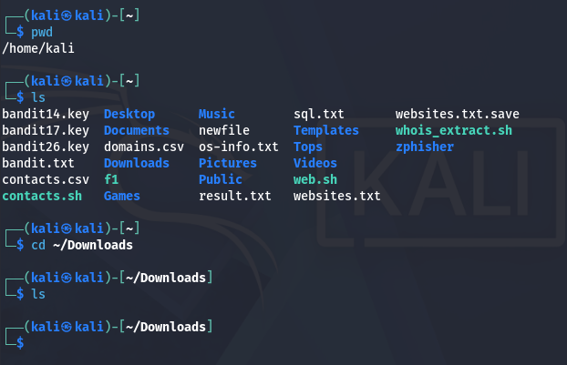

🔹 Task 3: Create a Directory and Three Files
Objective: Create a directory named music_playlist and three empty MP3 files using a single command.
Command:
mkdir ~/music_playlist && touch ~/music_playlist/song1.mp3 ~/music_playlist/song2.mp3 ~/music_playlist/song3.mp3
Verification Command
ls ~/music_playlist
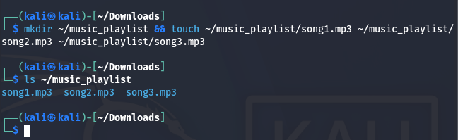
🔹 Task 4: Change Directory Permissions
Objective: Allow only the owner to have read, write, and execute permissions.
Command
chmod 700 ~/music_playlist
Explanation
Permission 700 means:
User | Permission
Owner | Read, Write, Execute (rwx)
Group | No Permission (---)
Others | No Permission (---)
Verify Permissions
ls -ld ~/music_playlist
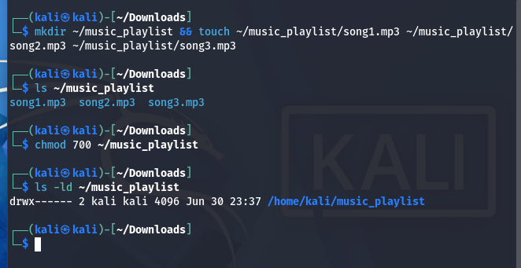
🔹 Task 5: Use the man Command
Objective: Find information about the grep command.
Command
man grep
One-Line Summary
Answer:
The grep command searches for specific words or patterns within files or command output and displays the matching lines.

